Program Information | [Lesson Title]  Show Me College Success Skills | TEACHER NAME  Susan Sheehan | PROGRAM NAME  Parma City Schools
Program Information | [Unit Title]  Postsecondary Transitions | NRS EFL  4 – 6 | TIME FRAME  240 – 360 minutes

Instruction | ABE/ASE Standards – English Language Arts and Literacy
Instruction | Reading (R) |  | Writing (W) |  | Speaking & Listening (S) |  | Language (L)
Instruction | Foundational Skills |  | Text Types and Purposes | W.4.2 W.5.2 | Comprehension and Collaboration | S.4.1, S.5.1 | Conventions of Standard English | L.4.1, L.5.1
Instruction | Key Ideas and Details | R.6.1 | Production and Distribution of Writing | W.4.3, W.6.1  W.4.4, W.6.2  W.4.5, W.5.3 | Presentation of Knowledge and Ideas | S.4.4, S.5.2  S.4.5, S.6.3  S.4.6, S.6.4 | Knowledge of Language | L.4.2
Instruction | Craft and Structure |  | Research to Build and Present Knowledge | W.4.6, W.6.3  W.4.7, W.5.4  W.4.8 W.6.4 |  |  | Vocabulary Acquisition and Use | L.4.3
Instruction | Integration of Knowledge and Ideas |  |  |  |  |  | Benchmarks identified in RED are priority benchmarks. To view a complete list of priority benchmarks and related Ohio Aspire lesson plans, please see the Curriculum Alignments located on the Teacher Resource Center (TRC).

 | LEARNER OUTCOME(S)  - Students will create a simple PowerPoint presentation as a means to share essay research. |  | ASSESSMENT TOOLS/METHODS  - Peer scoring rubrics for presentations.  - Teacher grading and peer editing of essay.
LEARNER PRIOR KNOWLEDGE

- Students have practiced using the essay writing process as they have written several essays.
- They have previously researched topics on the Internet and understand how to cite sources and avoid plagiarism.
- Students have created and saved essays using MS Word and flash drives.

 | INSTRUCTIONAL ACTIVITIES  - Begin class with a discussion on what it means to be successful. Then brainstorm together How Can We Help Ourselves Become Successful? This discussion should transition easily into the essay assignment on “Skills Needed for College Success”. Explain that after writing their essay, students will be presenting their findings to the class through a simple PowerPoint presentation. Review the writing process, including the OWL website on Conducting Research.  - Examine a model persuasive essay by viewing the website Guide to Writing a Basic Essay: Use this sample basic essay as a model. Small groups of students can also choose one college success skill from the list to research. They can interview current college students and professors and write their findings in a persuasive essay which can be used as the foundation of their PowerPoint presentations.  - Circulate and offer assistance, as needed, as students work in computer lab gathering evidence to support thesis statement, organize findings into outline form write draft essay. Use Types of outlines and samples for examples and guidance.  - Have students work with a peer on revising and editing steps of writing process. Complete final essay and save onto flash drive, along with outline. Collect printed essays and outlines as students complete their work.  - Discuss procedures for creating a PowerPoint presentation from a written essay. Review samples of PowerPoint presentations on writing, using Student Writing Workshop and The 5 Paragraph Persuasive Essay. Discuss what makes a good PowerPoint presentation, highlighting just some of those shown in the PowerPoint Presentation Advice handout.  - Demonstrate the MS PowerPoint software, creating a title slide and 5 other slides with text and graphics. Refer students to tutorials, if needed at the How to Make a Presentation in PowerPoint Format website. Have students practice creating 5-10 simple slides.  - Refer students to model persuasive essay examined by class in Step 2. Model for class a PowerPoint presentation that you have created for this essay called Thinking Matters. Use example to point out several PowerPoint tips that were discussed in Step 5 and what class’s focus should be when creating their own PowerPoint this time.  - Share PowerPoint Rubrics. Students refer to these as they discuss and formulate a class rubric for this first PowerPoint presentation.  - Explain that each PowerPoint presentation will be 2-3 minutes in length covering the main points of the student’s essay. Instructor will take care of technology worries this time. Circulate to offer assistance as students work to complete PowerPoint presentation, creating 5-7 basic slides, and saving presentation on same flash drive with essay and outline.  - Students will first rehearse giving their presentation to small groups of 2-3 classmates, gathering feedback based on rubric scoring. Students will then give their presentations to the entire class. As each presenter finishes, rest of class will score the presentation, using class rubric that was created. | RESOURCES  Computer with Internet access  Projector, ability to project  Purdue Online Writing Lab. (n.d.). Conducting Research. Retrieved from https://owl.english.purdue.edu/owl/section/2/8/  Use this Sample Basic Essay as a Model. (n.d.). Retrieved from http://lklivingston.tripod.com/essay/sample.html  Purdue Online Writing Lab. (n.d.). Types of Outlines and Samples. Retrieved from https://owl.english.purdue.edu/owl/resource/544/03/  Computers with Internet access, MS Word, and MS PowerPoint for student use  Flash drives for student use  Scoven, S. (2009, March 08). The 5 Paragraph Persuasive Essay [PPT file]. Retrieved from http://www.slideshare.net/swscoven1/the-5-paragraph-persuasive-essayii?qid=5804be13-febe-4476-9159-6d639fe0addf&v=&b=&from_search=1  Crespo, E. (2012, May 30). Student Writing Workshop [PPT file]. Retrieved from http://www.slideshare.net/ElianaCrespo/writing-tips-for-students?qid=50b8c036-fd74-4e7f-a68a-ad679eb0a6be&v=&b=&from_search=5  Student copies of PowerPoint Presentation Advice (attached)  Splane, M. (2006). PowerPoint Presentation Advice. Retrieved from http://www.cob.sjsu.edu/splane_m/presentationtips.htm  How to Make a Presentation in PowerPoint format. (n.d.). Retrieved from http://www.pppst.com/tutorials.html  Thinking Matters [PPT file] (attached)  Student copies of PowerPoint Rubric (attached)  PowerPoint Rubric [PDF file]. (n.d.). Retrieved from http://www.nclark.net/PowerPointRubric.pdf
DIFFERENTIATION

- Give students the option to work in pairs to develop their PowerPoint presentations.
- Give students the option to use an alternate presentation format, e.g. song or role play.
Reflection | TEACHER REFLECTION/LESSON EVALUATION
Reflection | ADDITIONAL INFORMATION  - Students will complete PowerPoint presentations for future writing assignments. Each time, the expectations will increase with the edited rubric reflecting this



Source: http://lklivingston.tripod.com/essay/sample.html

Use this Sample Basic Essay as a Model

The essay below demonstrates the principles of writing a basic essay. The different parts of the essay have been labeled. The thesis statement is in bold, the topic sentences are in italics, and each main point is underlined. When you write your own essay, of course, you will not need to mark these parts of the essay unless your teacher has asked you to do so. They are marked here just so that you can more easily identify them.

"A dog is man's best friend." That common saying may contain some truth, but dogs are not the only animal friend whose companionship people enjoy. For many people, a cat is their best friend. Despite what dog lovers may believe, cats make excellent house pets as they are good companions, they are civilized members of the household, and they are easy to care for.

In the first place, people enjoy the companionship of cats. Many cats are affectionate. They will snuggle up and ask to be petted, or scratched under the chin. Who can resist a purring cat? If they're not feeling affectionate, cats are generally quite playful. They love to chase balls and feathers, or just about anything dangling from a string. They especially enjoy playing when their owners are participating in the game. Contrary to popular opinion, cats can be trained. Using rewards and punishments, just like with a dog, a cat can be trained to avoid unwanted behavior or perform tricks. Cats will even fetch!

In the second place, cats are civilized members of the household. Unlike dogs, cats do not bark or make other loud noises. Most cats don't even meow very often. They generally lead a quiet existence. Cats also don't often have "accidents." Mother cats train their kittens to use the litter box, and most cats will use it without fail from that time on. Even stray cats usually understand the concept when shown the box and will use it regularly. Cats do have claws, and owners must make provision for this. A tall scratching post in a favorite cat area of the house will often keep the cat content to leave the furniture alone. As a last resort, of course, cats can be declawed.

Lastly, one of the most attractive features of cats as house pets is their ease of care. Cats do not have to be walked. They get plenty of exercise in the house as they play, and they do their business in the litter box. Cleaning a litter box is a quick, painless procedure. Cats also take care of their own grooming. Bathing a cat is almost never necessary because under ordinary circumstances cats clean themselves. Cats are more particular about personal cleanliness than people are. In addition, cats can be left home alone for a few hours without fear. Unlike some pets, most cats will not destroy the furnishings when left alone. They are content to go about their usual activities until their owners return.

Cats are low maintenance, civilized companions. People who have small living quarters or less time for pet care should appreciate these characteristics of cats. However, many people who have plenty of space and time still opt to have a cat because they love the cat personality. In many ways, cats are the ideal house pet.

PowerPoint Presentation Advice
Mike Splane © 2006
Source: http://www.cob.sjsu.edu/splane_m/presentationtips.htm

Structuring Your Talk:

Preparing a talk always takes far longer than you anticipate. Start early!
- Write a clear statement of the problem and its importance.
- Research. Collect material which may relate to the topic.
- Tell a story in a logical sequence.
- Stick to the key concepts. Avoid description of specifics and unnecessary details.
- If you are making a series of points, organize them from the most to the least important. The less important points can be skipped if you run short of time.
- Keep your sentences short, about 10-20 words each is ideal. This is the way people usually talk.
- Strive for clarity. Are these the best words for making your point? Are they unambiguous? Are you using unfamiliar jargon or acronyms?

Preparing Your Slides:

Presentation Design
- Don’t overload your slides with too much text or data.
- FOCUS. In general, using a few powerful slides is the aim.
- Let the picture or graphic tell the story. Avoid text.
- Type key words in the PowerPoint Notes area listing what to say when displaying the slide. The notes are printable.
- Number your slides and give them a title.
- Use the “summary slide” feature in slide sorter view to prepare an Agenda or Table of Contents slide.
- Prepare a company logo slide for your presentation.
- You can add a logo and other graphics to every slide using the slide master feature.
- Proof read everything, including visuals and numbers.
- Keep “like” topics together
- Strive for similar line lengths for text.

Visual elements
- A font size of 28 to 34 with a bold font is recommended for subtitles. The title default size is 44. Use a san serif font for titles.
- Use clear, simple visuals. Don’t confuse the audience.
- Use contrast: light on dark or dark on light.
- Graphics should make a key concept clearer.
- Place your graphics in a similar location within each screen.
- To temporarily clear the screen press W or B during the presentation. Press Enter to resume the presentation.

Text
- Font size must be large enough to be easily read. Size 28 to 34 with a bold font is recommended.
- It is distracting if you use too wide a variety of fonts.
- Overuse of text is a common mistake.
  - Too much text makes the slide unreadable. You may just as well show a blank slide. Stick to a few key words.
  - If your audience is reading the slides they are not paying attention to you. If possible, make your point with graphics instead of text.
  - You can use Word Art, or a clip art image of a sign, to convey text in a more interesting way.

Numbers
- Numbers are usually confusing to the audience. Use as few as possible and allow extra time for the audience to do the math.
- Numbers should never be ultra-precise:
  - “Anticipated Revenues of $660,101.83” looks silly. Are your numbers that accurate? Just say $660 thousand.
  - “The Break Even Point is 1048.17 units. Are you selling fractions of a unit?
  - Don’t show pennies. Cost per unit is about the only time you would need to show pennies.
- If you have more than 12-15 numbers on a slide, that’s probably too many.
- Using only one number per sentence helps the audience absorb the data.

Statistics
- Use the same scale for numbers on a slide. Don’t compare thousands to millions.
- When using sales data, stick to a single market in the presentation. Worldwide sales, domestic sales, industry sales, company sales, divisional sales, or sales to a specific market segment are all different scales. They should not be mixed.
- Cite your source on the same slide as the statistic, using a smaller size font.

Charts
- Charts need to be clearly labeled. You can make more interesting charts by adding elements from the drawing toolbar.
- Numbers in tables are both hard to see and to understand. There is usually a better way to present your numerical data than with columns and rows of numbers. Get creative!
- PowerPoint deletes portions of charts and worksheets that are imported from Excel, keeping only the leftmost 5.5 inches. Plan ahead.

Backgrounds
- Backgrounds should never distract from the presentation.
- Using the default white background is hard on the viewer’s eyes. You can easily add a design style or a color to the background.
- Backgrounds that are light colored with dark text, or vice versa, look good. A dark background with white font reduces glare.
- Colors appear lighter when projected. Pale colors often appear as white.
- Consistent backgrounds add to a professional appearance.
- For a long presentation, you may want to change background designs when shifting to a new topic.

Excitement
- Slides for business presentations should be dull! You don’t want to distract the audience.
- Sounds and transition effects can be annoying. Use sparingly.
- Animation effects can be interesting when used in moderation.
  - Too much animation is distracting.
  - Consider using animated clip art
  - Consider using custom animation
- You can insert video and audio clips into PowerPoint.
- You can also insert hyperlinks.

Hints for Efficient Practice:

Timing - Practicing Your Presentation
- Talk through your presentation to see how much time you use for each slide.
- Set the automatic slide transition to the amount of time you want to spend discussing each slide.
- Are you using the right amount of time per slide? Decide which slides or comments need alteration to make your presentation smoother.
- Change the automatic slide transition settings for individual slides to fit the amount of time needed for that slide and practice again. Are you still within the time limit?
- Decide if you want to remove the automatic slide transition feature before giving the presentation.

Content
- Make a list of key words/concepts for each slide
- Read through the list before you begin.
- Don't attempt to memorize your text;
- Your words will probably be different each time you practice.
- Think about the ideas, and your words will follow naturally.

Delivering Your Talk:

Pre-Talk Preparation
- Plan to get there a few minutes early to set up and test the equipment.
- Dress appropriately for your audience.
- Turn off your cell phone.

Handouts
- Edward Tufte, the leading expert on visual presentation techniques, advises speakers to always prepare a handout when giving a PowerPoint presentation.
- Make about 10% more handouts than you expect to use.
- Distribute handouts at the beginning of your talk.

Opening
- Jump right in and get to the point.
- Give your rehearsed opening statement; don't improvise at the last moment.
- Use the opening to catch the interest and attention of the audience.
- Briefly state the problem or topic you will be discussing.
- Briefly summarize your main theme for an idea or solution.

Speaking
- Talk at a natural, moderate rate of speech
- Project your voice.
- Speak clearly and distinctly.
- Repeat critical information.
- Pause briefly to give your audience time to digest the information on each new slide.
- Don’t read the slides aloud. Your audience can read them far faster than you can talk.

Body Language
- Keep your eyes on the audience
- Use natural gestures.
- Don’t turn your back to the audience.
- Don’t hide behind the lectern.
- Avoid looking at your notes. Only use them as reference points to keep you on track. Talk, don’t read.

Questions
- Always leave time for a few questions at the end of the talk.
- If you allow questions during the talk, the presentation time will be about 25% more than the practice time.
- You can jump directly to a slide by typing its number or by right-clicking during the presentation and choosing from the slide titles.
- Relax. If you’ve done the research you can easily answer most questions.
- Some questions are too specific or personal. Politely refuse to answer.
- If you can’t answer a question, say so. Don’t apologize. “I don’t have that information. I’ll try to find out for you.”

Length
- To end on time, you must PRACTICE!
- When practicing, try to end early. You need to allow time for audience interruptions and questions.

Demeanor
- Show some enthusiasm. Nobody wants to listen to a dull presentation. On the other hand, don’t overdo it. Nobody talks and gestures like a maniac in real life. How would you explain your ideas to a friend?
- Involve your audience. Ask questions, make eye contact, use humor.
- Don’t get distracted by audience noises or movements.
- You’ll forget a minor point or two. Everybody does.
- If you temporarily lose your train of thought you can gain time to recover by asking if the audience has any questions.

Conclusion
- Close the sale.
- Concisely summarize your key concepts and the main ideas of your presentation.
- Resist the temptation to add a few last impromptu words.
- End your talk with the summary statement or question you have prepared. What do you want them to do? What do you want them to remember?
- Consider alternatives to “Questions?” for your closing slide. A summary of your key points, a cartoon, a team logo, or a company logo may be stronger.

Assessment Rubric for PowerPoint Presentations
www.ohiorc.org/.../adlit/Units/000003/RubricPowerPoint.doc

 | Exemplary | Accomplished | Developing | Beginning
Organization | Information presented in logical, interesting sequence | Information in logical sequence | Difficult to follow presentation--student jumps around | Cannot understand presentation--no sequence of information
Subject Knowledge | Demonstrates full knowledge by answering all class questions with explanations and elaborations | At ease with expected answers to questions but does not elaborate | Uncomfortable with information and is able to answer only rudimentary questions | Does not have a grasp of the information. Cannot answer questions about subject
Graphics | Explain and reinforce screen text and presentation | Relate to text and presentation | Occasionally uses graphics that rarely support text and presentation | Uses superfluous graphics or no graphics
Research | Uses a variety of sources in reaching accurate conclusions | Uses a variety of sources in reaching conclusions | Presents only evidence that supports a preconceived point of view | Does not justify conclusions with research evidence
Screen Design | Includes a variety of graphics, text, and animation that exhibits a sense of wholeness. Creative use of navigational tools and buttons | Includes a variety of graphics, text, and animation. Adequate navigational tools and buttons | Includes combinations of graphics and text, but buttons are difficult to navigate. Some buttons and navigational tools work | Either confusing or cluttered, barren or stark. Buttons or navigational tools are absent or confusing
Oral Presentation  Elocution/Eye Contact | Maintains eye contact and pronounces all terms precisely. All audience members can hear | Maintains eye contact most of the time and pronounces most words correctly. Most audience members can hear presentation | Occasionally uses eye contact, mostly reading presentation, and incorrectly pronounces terms. Audience members have difficulty hearing | Reads with no eye contact and incorrectly pronounces terms. Speaks too quietly

Slide 1 | 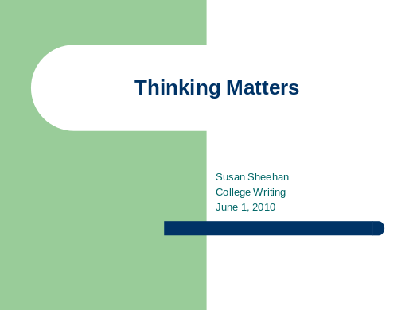
Slide 2 | 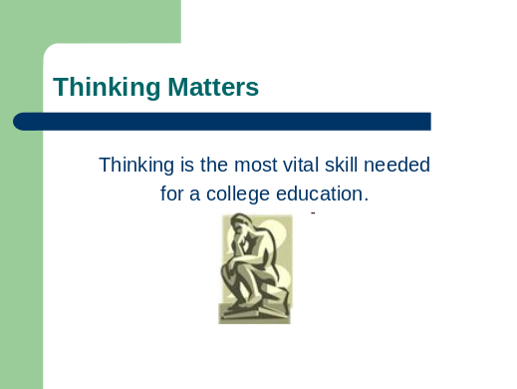
Slide 3 | 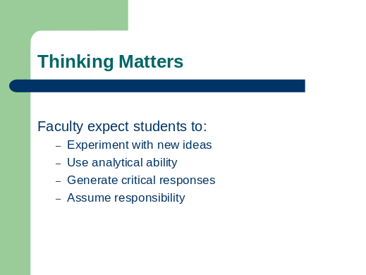
Slide 4 | 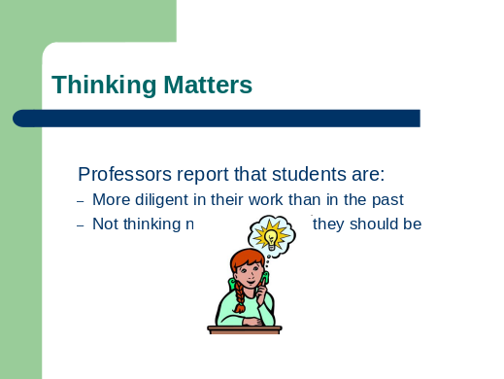
Slide 5 | 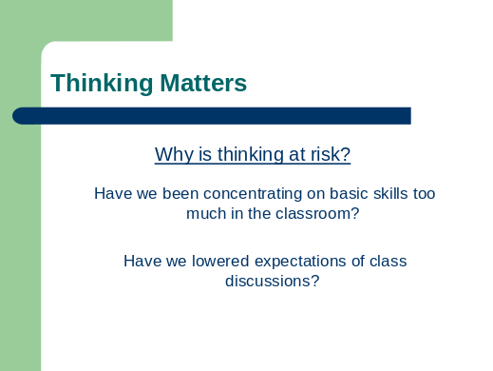
Slide 6 | 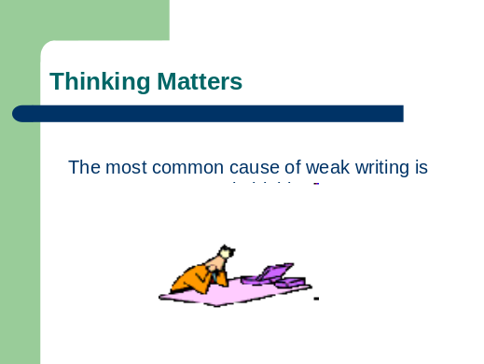
Slide 7 | 

